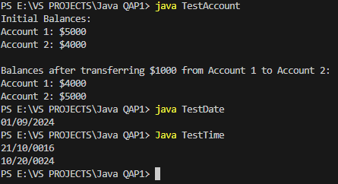

Question 1:

It took my roughly 5 hours to complete the project, with the first question taking slightly longer as I set up the basis of how to craft the other files.

Question 2:

The resources I used were class lectures to help as a reminder, and a few Youtube videos to get ideas on how to better structure my for statements within the code.

Question 3:

I asked a friend Michael O’Brien to help me spot a bug I had made with the code of Time.java where I had placed incorrect brackets in one of the if statements.

Question 4:

I did not ask any of my instructors for assistance on this project.

Question 5:

The difficulty of each question was fairly low, rating each equally at about a 4/10. I feel exceedingly confident in my ability to complete similar projects/problems with relative ease.